

Case management model

Version #: 5

Date of Release: April 2015

Report Developed by: Trust Zadzi, Clinical Social Worker
Contact information
Kidzcan Zimbabwe
6 Natal Road Belgravia
Harare
+263 42934168
Table of Contents
1. Background to Case Management 6
Benefits of Case Management 6
2. Case Management in the Context of Palliative Care 6
2.1 Pediatric Palliative Care 7
3. The Case Management Process in Zimbabwe 7
The Case Management System at Kidzcan 8
3.1. Step 1: Identification of children 8
3.1.1 Future Identification of Children 8
3.2. Step 2: Assessment of children and their families 9
3.3 Communicating with Children 10
3.4 Guidelines for communicating with children 11
3.5 Confidentiality 11
4. Step 3: Care Planning 11
4.1. Step 4: Implementation of the care plan 12
5. Step 5: Monitoring and Case Review 13
6. Step 6: Case Closure 14
7. Facilitating the Case Management Process 14
7.1. Case facilitation 14
7.2. Case Conferencing 14
7.3Core meetings 15
7.4. Support group meetings 15
7.6 Discharge Planning 15
8. Inter-agency Referral System 16
8.1. Kidzcan –HOSPAZ Referral Pathway 17
8.2. Follow-up and Feedback 18
9. Documentation 18
10. Child/Family Advocacy 19
11. Supervision in Case Management 19
References 20

Acknowledgements
All individuals and organizations who contributed in the development of this case management model are hereby acknowledged and appreciated for their invaluable ideas and support. Reference was made to the HOSPAZ and Ministry of Public Service Labor and Social Welfare case management models. The following individuals are also appreciated for professional guidance and moral support; these include Carol Wogrin; palliative care specialist Jenny Hunt; Kidzcan director Bev Sebastian; Christina Zaveri; doctors at Sekuru Kaguvi Eye Unit, nurses and doctors in the A4, A5 and A6 oncology wards at Parirenyatwa Group of hospitals; doctors at Harare Hospitals and colleagues in the palliative care fraternity.

Foreword

Kidzcan is the only Zimbabwean Private Voluntary Organization dedicated to increasing the survival rate of children with cancer and related blood disorders. Kidzcan’s mission is to see a compassionate world where children with cancer are given the chance to live healthy and fulfilling lives. Originally set up to provide psychosocial support to children undergoing treatment, the fragile socio economic climate and challenged public health system has resulted in Kidzcan sourcing and paying for drugs and lifesaving diagnostic tests for treatment.

Kidzcan’s mission is to increase the survival rate of children diagnosed with cancer in a loving and caring environment. There are many mitigating factors that are preventing this mission from being achieved. A continuum of care and provision of psychosocial support once the children are discharged from the hospital has also been lacking within the current system due to lack of a clear referral system. One of the key reasons for this is that there is one dedicated pediatric oncology unit in the country and patients that Kidzcan supports are treated in this unit. The unit is based in the capital Harare. Kidzcan has found on numerous occasions that once patients leave the hospital some do not always return. They default on treatment, return when their cancers have progressed considerably and the prognosis is poor, or die at home but without adequate pain management, and support of the patient and family. One of the major challenges in this area is that there is no adequate case management and linked to this a referral system to ensure patients and their families’ access the palliative care that they require in their communities once discharged from hospital. A referral system is important to ensure patients return for compliance to treatment. We believe that by developing a case management and referral system within the confines of existing structures Kidzcan will decrease the default rate which we hope will result in improved treatment outcomes.

In this light Kidzcan wishes to ensure its vision - to see a compassionate world where children with cancer are given the chance to live healthy and fulfilling lives - is realised through the implementation of an effective case management system. The aim of the case management system is to standardize the approach on how children and their families are managed and cared for by health care personnel and volunteers. The overall aim of case management is to ensure that the children who need care and support are identified, assessed, interventions provided and ongoing follow up is conducted.

Effective case management and a referral system are critical to treatment outcomes for children living with cancer and associated blood disorders in Zimbabwe. Kidzcan has employed a Clinical Social Worker who will receive continuous palliative care training from Island Hospice and a supervisor that specializes in palliative care. This person will set up and then coordinate case management of patients with the clinicians on the wards to ensure that at admission and discharge the requisite support that patients and their families require is determined and documented. There is no case management system in existence at a clinical setting within the Ministry of Health although the Department of Child Welfare is expected to finalise a draft Case Management model in the near future.

This document provides guidance on how to integrate clinical and psychosocial support services during the provision of care and support to children presenting with cancer or blood disorders and those whose illness does not respond to curative treatment. To achieve the intended quality care outcomes it is envisaged that Kidzcan will work in collaboration with other child focused organizations to ensure holistic provision of care.

Kidzcan will partner with HOSPAZ (the national coordinating body for palliative care providers). HOSPAZ will act as a broker between its members and Kidzcan when a child requires assistance in the community. A referral pathway will be put in place to ensure a continuum of care for children with cancer. This document acknowledges the Department of Child Care and probation services’ National case management model as there is need to work with existing structures. Child care workers feed into this case management model at a national level as they are community cadres selected at the ward or village level and work with home based caregivers.

This model shall be a working document for Kidzcan staff, partners, volunteers and health care practitioners. We hope the proposed system will help save the lives of children with cancer through quality health care outcomes. This document is informed by the Kidzcan survey on gaps and status of the management of children with cancer in the health service delivery system. The survey was carried out by Kidzcan targeting doctors, nurses, parents, children and professionals in the palliative care fraternity.

This model was developed following professional guidance from experts in the field and findings from interviews held with Kidzcan staff and volunteers, doctors, nurses, children, palliative care professionals and parents/caregivers. Parents’ views were sought during support group meetings. Literature on the subject including the Cancer Control Strategy and other cancer related documents were also consulted.

1. Background to Case Management
The Case Management Society of America cites case management as a collaborative process of assessment, planning, facilitation and advocacy for options and services to meet an individual’s health needs through communication and available resources to promote quality cost-effective outcomes.

In case management the practical aspects of providing comprehensive care to children who are in need of care at the time of illness and in the event of bereavement are also explored .It is important to ensure continuum of care through linkages and referrals from the point of diagnosis including children that die.
The following steps are taken;

- Identification of patients and families
- Assessment of patient needs.
- Planning interventions required
- Implementation of the strategies.
- Documentation and record keeping
- Referrals
- Monitoring and evaluating progress
V II. Advocacy on behalf of children and families and empowering them

Benefits of Case Management
- It ensures the coordination of services provided by multiple stakeholders to meet comprehensive care of clients.
- It strengthens assessment ability of care providers
- It ensures follow up of the client thereby improving quality of care
- It strengthens documentation.
- Encourages sharing of information and experiences by all involved in care as well as by children and families.
- It ensures a continuum of care through effective referrals and linking clients with needed services.

2. Case Management in the Context of Palliative Care
“The goal of palliative care is to, relieve suffering, optimize functioning and provide personal growth opportunities for children with life threatening conditions such as cancer and their family members. Palliative care should be initiated regardless of the stage of the disease or the need for other therapies. Palliative care is both a philosophy of care and an organized, highly structured system for delivering care” (Foster, 2012:18). Palliative care expands traditional disease-model medical treatments to include the goals of enhancing quality of life for the patient and family, optimizing function, and helping with decision making, and providing opportunities for personal growth”.

Case management enhances palliative care as it is the holistic aspect of providing comprehensive care to children who are in need of care throughout illness and bereavement. Palliative care providers should cater for the child and families; (1) physical, (2) mental, (3) social, and (4) spiritual needs. These four domains become the guiding principles in case management from the initial contact with the child and family to the point of case closure.

2.1 Pediatric Palliative Care
Critical elements of pediatric palliative care according to WHO are as follows;

- It is the active total care of the child’s body, mind and spirit and also involves giving support to the family.
- It begins when a life threatening illness is diagnosed and continues regardless of whether or not a child receives treatment directed at the disease.
- Health providers must evaluate and alleviate the child’s physical, psychological and social distress.
- Effective palliative care requires a broad multi-disciplinary approach that includes the family and makes use of available community resources. It can be successfully implemented even if the resources are limited.
- Palliative care integrates advanced planning as part of the care in preparing the family and is concerned with healing rather than curing.
- Access to information also facilitates patient autonomy and choice.
- It can be provided in tertiary care facilities, in community health centers and even in children’s homes.

Per the survey carried out by Kidzcan the doctors and nurses receive limited training in pediatric palliative care. These practitioners also rotate due to study requirements. This leaves a gap in the continuum of care for cancer patients and there is need for training to ensure that the above elements are achieved.

3. The Case Management Process in Zimbabwe
The process ensures the provision of comprehensive quality care by all stakeholders involved in the provision of services to children and their families. Figure 1 below illustrates the case management conceptual framework The steps taken are intake, assessment, case planning, monitoring and review and lastly case closure.

The National Case Management System Conceptual Framework

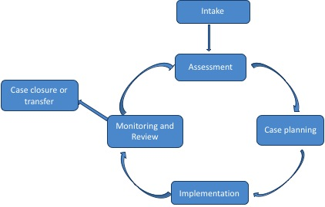
Fig 1. Adapted from the NCMS

The Case Management System at Kidzcan

3.1. Step 1: Identification of children
1. Children come to Parirenyatwa and they arrive at the casualty department. If further medical intervention is needed child is referred to A2 pediatric ward where decision to admit child is made (A2 is the entry point for all pediatric patients admitted at Parirenyatwa).

2. At A2 the patient is seen by a general practitioner. The General Practitioner may take blood samples, prescribe tests etc. depending on how the child presents. The patient may be admitted directly to another ward, including A4 special ward, or may stay on A2’s observation ward or be seen in A2’S pediatric casualty if the child is in a critical condition.

3. Kidzcan staff will get request slips from the nursing staff and doctors on A4 special ward after a cancer diagnosis has been confirmed and the child has been admitted. The request slips are left in a Kidzcan box at the nurse’s station. Each child is then registered and a Patient Profile Form (PPF) is completed with the family. The patient is enlisted for assistance after assessment by the Kidzcan Clinical Social Worker.

3.1.1 Future Identification of Children
Kidzcan has for the last 4 years run an early detection programme with support from TEAR Australia. 2015 will be the last year this programme runs. Kidzcan has visited every Provincial Headquarter and educated health professionals, traditional medical practitioners and other community workers about the signs and symptoms of childhood cancer. Education materials are also distributed at the time of the workshops including Early Detection Posters and information booklets. In addition, Kidzcan during these workshops discussed with workshop participants the referral system in Zimbabwe and the importance of effective and speedy referrals to the next level within the health care system. This is critical to ensure patients gain access to appropriate diagnosis and treatment. Thus as a result of these early detection workshops, patients will have an increased chance of survival. Kidzcan has not managed to assess whether the workshops have resulted in referrals.

Opportunities exist for home based caregivers or child care workers to be equipped with skills and knowledge to identify children in the community who require oncology services through observation and approaching children presenting with signs and symptoms of cancer. Referrals should be made to the nearest health centre or Parirenyatwa. Kidzcan could in the future scale up cancer awareness programmes and workshops in communities in partnership with Ministry of Health and Child Care to increase early detection of cancer by caregivers, nurses and doctors. The parents/caregivers can approach palliative care providers or health institutions for information. Identification of patients and their families is also done through clinics, hospitals and community referral. Identification of children with cancer can also be done by teachers through the education system and training will be implemented by Kidzcan with support from the Ministry of Education.

3.2. Step 2: Assessment of children and their families
1. On admission a psychosocial assessment of clients is made by Kidzcan officers to understand the background information which will form the basis of continued care.

2. Child will be registered using the patient profile form see appendix1. When registering clients the following principles apply.

- A genogram is used to obtain client information. A genogram is a family tree that shows the child’s support system and relationships.

- Kidzcan officers, doctors and nurses should observe and listen to verbal and non-verbal cues during an interview with the client.

- Assessment of the family both its structure and function is an important component of the history taking process. The functional relationship between the child and the family is a major factor in emotional and physical health, thus the need to know composition of the family and the relationships among its members as this has an impact on the support and care aspects.

- Cultural and spiritual issues have to be considered during assessment as the healing of a sick child is also dependent on these issues being addressed. (Hockenberry and Wilson; 2009)

3. Below are some of the issues that will be included in the initial assessment. Standardized tools may employed at the discretion of the officer in order to assess the following;

- Personal Data
- Health status
- Disease process and prognosis
- Emotional Status (psychosocial wellbeing assessment tool)
- Cognitive Functioning (Fica tool)
- Functional Status
- Spirituality and cultural Issues
- Patient Support System and caregiver Support System
- Financial Status

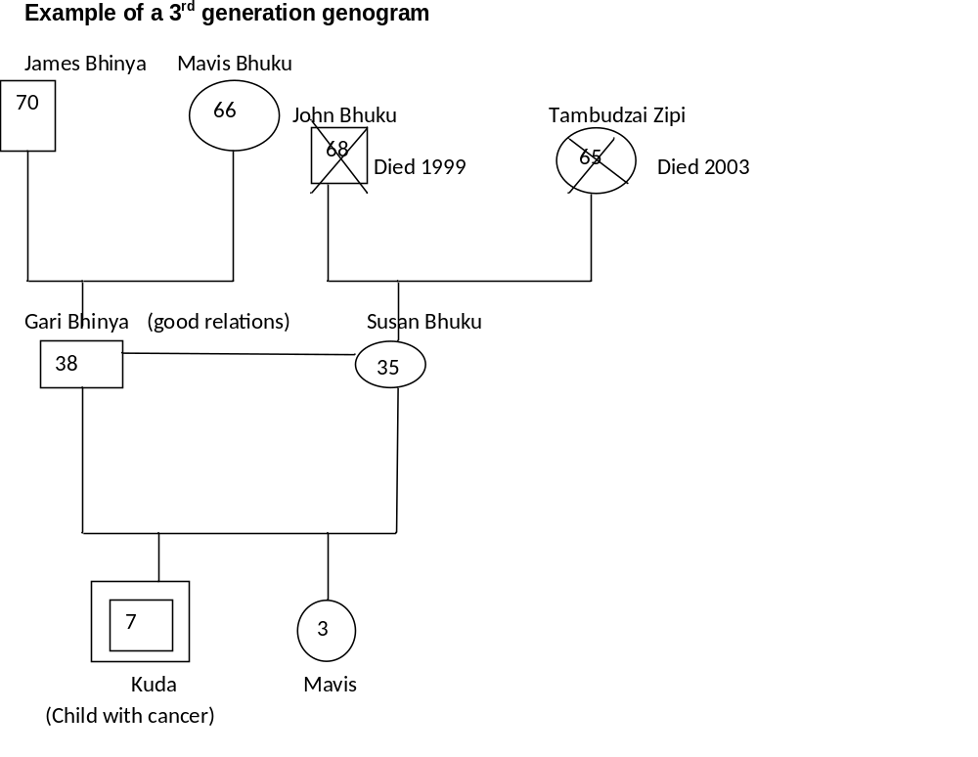

3.3 Communicating with Children
‘’For many adults it is not always easy to find the words to talk about ideas and feelings. It is even harder for children. Emotions take many forms, such as crying, screaming, running, away and being angry” (HOSPAZ, 2012: 65). Pediatric care should be understood from a developmental perspective hence the need to differentiate infants, those in early childhood, school going age and adolescents. Children communicate pain, emotions and feelings differently and according to their age and cognitive maturation. Developing a good relationship and rapport with children is vital and is the first step towards good patient care. In communication with children of all ages nonverbal components of the communication process convey the most significant messages. “In a survey of 50 children with cancer aged 8-17, 95% of patients wanted to be told if they were dying” (Carol and Finlay 2010, 515).This shows a need to communicate directly with the child about end of life issues. The use of drawing, art and play therapy is important to understand the child’s fears, hopes, worries and pain. Volunteers will also play an important role in psychosocial support.

3.4 Guidelines for communicating with children
Wong’s Essentials of pediatric nursing, (2009)
- Allow children time to feel comfortable and ensure confidentiality
- Avoid sudden or rapid advances, broad smiles, extended eye contact ,and other gestures that may seem as threatening
- Communicate through transition objects such as dolls, puppets, and staffed animals and use a variety of communication techniques
- Give older children the opportunity to talk without the parents present
- Assume a position that is at eye level with the child
- Speak clearly, be specific and use simple words and short sentences
- Be honest with children
- Allow children to express their concerns and fears/emotions

Using the above guidelines the following steps should be taken:
- Take child to private room with mother or caregiver
- Register the child on the PPF
- Ask background information
- Ask about the diagnosis
- Give information on Kidzcan services

3.5 Confidentiality
Confidentiality is the practice of retaining and not divulging or using information gained as a professional through the process of gathering information on a child’s and his or her family. Documents and information of a personal nature have to be treated with the utmost care and not allowed to be read or accessed by other employees or others outside the organization. Specific procedures will apply to the sharing of information between professionals and organizations. A system which ensures the client’s privacy and identifying information will be maintained.

4. Step 3: Care Planning
The Care Plan defines what action will be taken, by whom and when in order to make sure the child’s needs are met. The Clinical Social Worker will play an active role in the planning for care and will involve the child, parents, doctors, nurses and other community support systems in the planning for service provision. This document will outline how the needs from assessment and planned activities for an individual patient will be addressed. The Clinical Social Worker will update the Kidzcan files according to the feedback given by palliative care providers and medical practitioners. (See Care Plan Form).

4.1. Step 4: Implementation of the care plan
Implementation entails the execution of the care plan. Doctors and nurses in A4, A5, A6 and C3 wards, Sekuru Kaguvi and Harare hospital are involved in the implementation of care plans. Below, are some of the services to be included in the care plan as outlined in the Kidzcan standard operating procedure:

Lab tests
- Doctors complete requests for tests in duplicate and put them in Kidzcan box at A4 sp ward nurse’s station regardless of the ward the child is on. Kidzcan officer authorizes by stamping, putting Kidzcan number and signing.
- Return one copy of request to the parent or back to the doctor this depends on child’s medical condition .If child is weak hospital will organize transport to the lab. Kidzcan will keep one copy of the request.
- Parents will take a copy of the signed request form to the laboratory service provider. If a child is not accompanied by his or her parent or caregiver, Parirenyatwa staff will take the child for the tests. Results are sent back directly to Parirenyatwa by the lab.
- Pediatric oncology consultant must approve procedure of bone marrow aspirants. Kidzcan officer stamps, signs and puts Kidzcan number on request form. Requests are made in duplicate.
- Doctor will book the bone marrow aspirant procedure with the laboratory.

Diagnostic tests
- Requests for scans are made in duplicate and placed in Kidzcan box at A4 sp ward. Kidzcan officer will collect sign and stamp. All requests are screened by the pediatric oncology consultant
- Kidzcan officer will check the request form to confirm date, age, ward, OPD or hospital number, doctor’s signature and clinical history of patient.
- Kidzcan will liaise the relevant service provider and if it is an outpatient request form it must have the telephone number for the parent or caregiver to be advised on the appointment. If the patient needs scan review the Kidzcan officer must retain the request form and ensure the parent has put their telephone number on the OPD request form.
- Upon approval Kidzcan will act by delivering the request to the service provider. One copy of the request is kept by the service provider. The other copy is kept by Kidzcan and filed. The Kidzcan officer waits for the bookings to be made for each patient referred. Kidzcan officer retains the booking forms which contain specific instructions prior to testing (i.e. fasting,) and handover to the sister in charge who ensures that the child gets to the appointment and organizes transport to and from the service provider. Results are delivered to A4 sp ward by the service provider. Delivery will include the results for A4 special, Harare hospital and Sekuru Kaguvi.
- Parents with children at Harare Hospital will collect results from A4 sp ward. Kidzcan officers can also deliver results on Tuesdays and Thursdays when they visit Harare Hospital.

Transport assistance
- Kidzcan will provide transport fares in order to ensure compliance with treatment. Amount disbursed will be based on geographic location and standardized rates will be determined by Kidzcan.
- Transport will be paid for one parent and the patient. (If a child will sit on their caregivers lap no transport money will be disbursed for the child).
- Only assessed and eligible clients will receive bus fares. All transport disbursement must be recorded in a register by the logistician. If possible bus tickets should be retained.

NB: During the weekend nurses and doctors will be assisted by a Kidzcan officer on call.

Blood assistance
- Doctors make requests for blood and blood products using a blood transfusion services form and place it in the Kidzcan box in the A4 ward .This applies for A4 special, C3, A6 wards and Sekuru Kaguvi eye clinic. Once endorsed Kidzcan will return form to Nurse/clinician in charge of bringing it to NBSZ
- Requests for blood by doctors at Harare hospital are brought to A4 special by the Nurse or caregiver and approved by a Kidzcan officer on duty. However some requests can be approved on Tuesday and Thursday by the Logistician during visits to Harare Hospital.
- Blood disorder patients will purchase the blood at a discounted price. This is an agreement between Kidzcan and NBSZ however their requests go through the same procedure.
- In cases of emergency during the weekends a roster with contact numbers for Kidzcan officers on call will be made available to all relevant wards. Requests are approved on the phone and sent to Blood transfusion services Zimbabwe.

NB: Doctors cannot request for blood in advance.

Prosthetic eyes
- After enucleation nurses will phone Kidzcan or refer client directly to purchase prosthetic eyes. Client returns to SKH for the eye insertion procedure.
- Kidzcan will sell prosthetic eyes to clients at a nominal fee of $20-00.
- Doctors phone Kidzcan to collect request forms for scans, chemotherapy and lab tests or leave request at A4 sp ward.

Shunts
- Doctor will write a request for a shunt in duplicate .Shunt request should specify that the procedure is for a child with cancer. Doctor must specify type of shunt requested ie low, medium and high pressure. The request forms must be dated, have patient’s full name, hospital number, stamp and doctor’s signature. Doctor will put request in Kidzcan box.
- Kidzcan officer must check form and only act when all information is on the form Request form will be stamped, signed and put Kidzcan number.

5. Step 5: Monitoring and Case Review
- Monitoring of the child’s status and health progress will be done by doctors and nurses.
- Kidzcan monitoring and evaluation department will also monitor if psychosocial support services are going according to plan through gathering of data and statistics on service provision.
- After discharge from the hospital phone follow ups will be done by Kidzcan to ensure clients come back for clinical reviews.
- Case reviews will be done by the Clinical Social Worker to check if the child’s care plan is on track and continues to meet the child’s needs and if the implementation of the plan is progressing. This will determine whether the plan remains relevant; and if not, make necessary adjustments to the plan which should be documented in the Care Plan.
- The nature of the case should determine the frequency of the case reviews, but at a minimum a formal review should be conducted at intervals of not more than six months. This model also acknowledges the medical case review for ongoing clinic visits by the child.
- An overview of the process from referral to death is provided by means of mortality and morbidity meeting. (See section 7.5).Case conferencing attended by all pertinent personnel is one forum for case review (see section 7.2.)

(See Case Review Form)

6. Step 6: Case Closure
A case can be closed at the point at which work with the child ends because the:

- Health has been restored and there is no evidence of cancer, i.e. the case plan has been completed, child’s needs have been met and the child no longer requires support;
- Child moves out of the area and cannot be located despite significant efforts;
- When the Child dies and bereavement and grief counseling has been provided to caregivers.

The decision to close the case must be recorded on the care plan, including the reasons and the person who authorized case closure. (See Case Closure Form)

7. Facilitating the Case Management Process

7.1. Case facilitation
Case facilitation is the coordination of services being provided to the child. This includes referrals, access to counseling and psychosocial support services, support groups and access to other basic services. The Clinical Social Worker will facilitate development of care plans, case conferences, family conferences and case reviews.

7.2. Case Conferencing
The Case Conference is a discussion to share information about assessment, diagnosis and prognosis. Comprehensive case review may be a feature of case conference. It helps the child and family understand better about the illness, treatment process and procedures. Case conferences may be called on a regular basis to update ,review and assess. The Case Conference meeting should be coordinated by the Clinical Social Worker, who is the person responsible for making sure that a child receives all of the services they need. At community level this may be the home based care giver, probation officer, or lead child care worker who is the focal person in the community under the department of child welfare and probation services.

People involved in a case conference include pertinent people involved in the treatment, provision of care and support to the child and family, and those with information about the child’s treatment and care. Participants might include social workers, doctors and nurses, representatives of any NGO working with the child and members of the child’s family and where appropriate the child should be included. Decisions should be made using the principle of best interest of the child. The initial case conference should be conducted within 5 days of receipt of the child’s admission or at the discharge from hospital. Due to scarcity of time serious cases will be given priority and these will be identified during ward rounds every week. In some cases phone calls will have to be used to arrive at a conclusive decision.

7.3Core meetings
These are internal Kidzcan meetings which are held every Wednesday in the morning. During the meetings care plans are discussed and cases are reviewed .If any changes to the care plan are necessary they will be raised and minuted for actioning by the relevant Kidzcan officer or agency. The core meetings act as a debriefing platform and support system for the Kidzcan staff members.

7.4. Support group meetings
“Receiving a cancer diagnosis often triggers a strong emotional response. Although some people experience shock, anger, and disbelief, others may feel intense sadness, fear, and a sense of loss” (Asco, 2005). Support groups are meant to provide psychosocial support to the children and parents in a group setting.

The Kidzcan Clinical Social worker will facilitate the meetings with the help of the nurse. The meetings will be held once every week every Thursday at 14:00-15:00. Parents will be consulted during the meetings to up come with an agenda. Issues to be discussed include how the children and parents are coping after cancer diagnosis. The meetings will be held in collaboration with the Parirenyatwa nursing staff so that all the medical and psychosocial issues can be addressed. In an endeavor to provide comprehensive information and education, the Social Worker may invite doctors, dietician/nutritionist, and psychologist to speak with the group. The Social Worker will liaise closely with the ward counselor to address issues that arise.

7.5 Morbidity and mortality Meetings
These are multi-disciplinary coordination meetings usually held after the death of a child that can provide useful information. They will include pertinent professionals providing service to the child. They are held to discuss issues surrounding provision of quality services, morbidity and mortality on what is causing deaths and how services can be improved in the future as well as other clinical and psychosocial care issues. The meetings should involve Doctors, Nurses, Social worker, Pharmacist, Infection control/microbiologist and radiologist. This is an ideal standard and depends on buy-in from the MOHCC.

7.6 Discharge Planning
Children and their family members should be prepared for discharge. They will need adequate information about infection control, how and when to take medication and the next review date. The multi disciplinary team of doctors, nurses, social workers and psychologists should ensure that the child is properly discharged using a standardized discharge plan. This will be lead/coordinated by Kidzcan. A standardized discharge plan for the pediatric oncology ward will ensure that the child is safely reintegrated back into the community with known support systems. Kidzcan will ensure that children come back for reviews through follow up phone calls when needed and provision of bus fares to needy clients. The child and family should be spiritually and psychologically prepared to go back home and linkages made with community palliative care providers for a continuum of care.
(See Discharge Checklist Form

8. Inter-agency Referral System
To avoid parallel structures this document acknowledges the National Case Management System (NCMS) developed by the department of Child Welfare and Probation Services. The NCMS is essential when referring children to access services in the community. All assessed clients with financial challenges will be referred to the resident Medical Social Worker at Parirenyatwa. The Medical Social Worker will refer the client to the Department of Child Welfare and Probation Services for an Assisted Medical Treatment Order (AMTO). All agencies operating in the system should have a referral focal person to facilitate ease of follow up on referrals these include lead case care workers, social workers, and HBC caregivers.

Doctors at the A4, A5, A6 & C3 wards and Sekuru Kaguvi Eye Clinic will refer children with cancer to Kidzcan for supportive services. The MOHCC will coordinate all clinical services provided by health professionals. MOHCC and Kidzcan will ensure a continuum of care by referring the child to local clinics, hospitals, CBOs and NGOs for relevant services. A referral form should always be signed by a doctor and should have a tear off slip or duplicate copies that enable both the referrer and the recipient of the referral to maintain a copy of the original referral. Children in need of services like such as scans, prosthetic eyes and bus fares are referred to Kidzcan for assistance by the doctors.

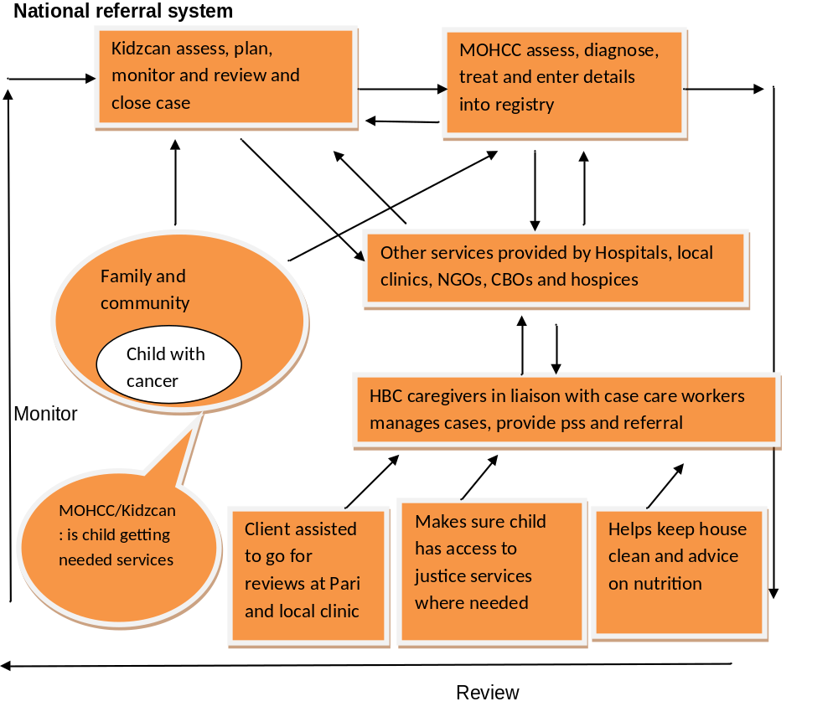

Fig 3

8.1. Kidzcan –HOSPAZ Referral Pathway
The HOSPAZ referral directory with community based structures i.e. CBOs, HBC and palliative care providers will be used to refer children to and from the hospital. Referrals are made to link children and families to appropriate service providers for grief and bereavement counselling services (with consent). HOSPAZ will act as broker between Kidzcan and its members and will in turn give feedback to Kidzcan on services provided .Update meetings will be held once every quarter with the Kidzcan Clinical Social Worker and HOSPAZ focal person. If HOSPAZ is not able to act as a broker Kidzcan will go direct to the HOSPAZ partner.

Request to Hospaz
Service agreement
Outreach required

Case closed
Kidzcan services

Fig 4

8.2. Follow-up and Feedback
When a referral is made to a service provider, it is essential that there is follow-up and feedback. It is the responsibility of the:

- Referring agency to follow up in order to be sure that the provider being referred to acts on the referral, e.g. meets with the child and or family.
- Provider receiving the referral not only to act on the referral, but to give feedback to the referrer about the action taken with the referral and the plan for moving forward.

Both of these steps are important to ensure well-coordinated care to the child in need. Regardless of the method by which the feedback is given, whether verbal or written, it must be documented in the case record.

9. Documentation
“Clear, concise, and ongoing documentation of social work practice facilitates clear communication with other service providers and organizations, thereby promoting continuity of services”(NASW, 2013). Proper record keeping is an imperative component in health care delivery. Records give service managers the information they need to make sound and appropriate decisions in care and support. Case management plans of care are developed and documented in the patient’s medical record and are located strategically for access and notice by all relevant and authorized professionals involved in a patient’s care. Documentation focuses on new and pertinent information relevant to the current/proposed course of treatment or future planning. Social Work Case Management and all Medical Record Documentation is confidential in nature and should be treated accordingly hence the Clinical Social Worker will also ensure that the children’s case files are well documented filed and stored in safe place at Kidzcan. Documentation will also involve upgrading of the Information and management system (IMS) for an improvement in accessing the information on cases and retrieval of the same from the database.

When compiling child’s information the following should be prioritised; At the time of registration, referral and or follow up:

- Date the information
- Record information under the appropriate headings and sections
- Be consistent in the information
- Be comprehensive
- Collect information at the right time
- Record complete information
- Ensure that information is legibly written
- Put signatures always

NB: Officers should carry the necessary stationery provided by the responsible organization to facilitate data collection. Information not recorded is work not done.

10. Child/Family Advocacy
“Effective advocacy involves helping case management clientele identify and define their strengths, needs, and goals and communicate those needs and goals to service providers and decision makers.”In an effort towards personal empowerment the Clinical Social Worker will advocate on behalf of children and parents if service providers are not responsive to their needs. Kidzcan staff should always be proactive and alert to ensure that every child is given the right to fight and survive cancer. It is the right of every child to have access to health as outlined in international conventions and national policies.

11. Supervision in Case Management
The emotional burden of working with children diagnosed with cancer makes supervision an essential and integral part of case management. Supervision is also part of continuing education required for the skillful development of professionals and volunteers. “Supervision protects clients, supports practitioners and ensures that professional standards and quality services are delivered by all who are involved in the care of children’. Therapeutic support, debriefing and professional supervision for anyone who is working with the children is recommended. Monthly supervision is a formal system of support to the worker, and monitoring the performance and adherence to set care standards”. Monthly group meetings will be used for group supervision of volunteers.

The broad functions of supervision are the following:

- Promote the provision of quality of care;
- Development of knowledge and skills;
- Prevention of secondary trauma, compassion fatigue and burnout;
- Provides a platform for the sharing of experiences and concerns of the care workers i.e. doctors, nurses, psychologists, counselors, volunteers ,social workers and other support staff
- The assessment of care worker performance.
(See Supervision Form).

References

- American Society of Clinical Oncology (2005) http://www.cancer.net/coping-and-emotions/managing-emotions/finding-support-and-information/support-groups
- Carroll William ,L and Finlay Jonathan (2010) Cancer in Children and Adolescents ,Replica press pvt, ltd
- Case management society of America (2008-2014) www.cmsa.org
- EAPC taskforce(2009)Palliative care for Infants Children and Young People, The Facts, http://www.eapcnet.org/projects/PaedriaticTF.html
- Foster Terrah L, Bell Cynthia J, McDonald Carey F, Harris Joy S, Gilmer Mary Jo, Nursing: Research and Reviews 2012:2 17–25,http://www.dovepress.com/nursing-research-and-reviews-journal
- Hockenberry Marylin.J,Wilson David (2009) Wong’s Essentials of Pediatric Nursing ,Elsevier
- Hospaz, (2012) Situation Analysis Report on Palliative Care in Zimbabwe
- Hospaz (2012)Palliative care for children, A training Manual for Health Professionals and Communities in Zimbabwe
- National Case Management System For The Welfare And Protection Of Children In Zimbabwe,(2013)GOZ
- National Association of Social Workers (2013),Case management standards; http://www.socialworkers.org/practice/naswstandards/CaseManagementStandards.pdf
- WHO (1996) Guidelines cancer pain relief (2nd edition),World Health Organisation,Geneva

Case management society of America, 2008-2014 (CMSA)
Foster et al. 2012:2 17–25 Nursing: Research and Reviews ,Dovepress
WHO (1996) Guidelines cancer pain relief (2nd edition),World Health Organisation,Geneva
Hospaz (2012)Palliative Care for Children ,A Training Manual for Health Care Professionals and Communities in Zimbabwe
Carrroll William , and Finlay Jonathan, (2010) Cancer in Children and Adolescents ,Replica press pvt ltd
Hockenberry Marylin.J,Wilson David (2009) Wong’s Essentials of Pediatric Nursing ,Elsevier
American Society of Clinical Oncology (2005) http://www.cancer.net/coping-and-emotions/managing-emotions/finding-support-and-information/support-groups
National Association of Social Workers(2013) http://www.socialworkers.org/practice/naswstandards/CaseManagementStandards.pdf
National Association of Social Workers (2013) Standards for Social Work Case Management http://www.socialworkers.org/practice/naswstandards/CaseManagementStandards2013.pdf

